Relationships in Object-Oriented Design (LLD)
Relationships describe how two classes interact with each other.
Think of them as different levels of connection between objects.
Weakest ------------------------------------------------> Strongest

Dependency → Association → Aggregation → Composition → Inheritance/Realization
The biggest interview mistake is confusing Aggregation and Composition. The key difference is ownership and lifecycle.

1. Dependency (Uses)
A dependency means one class temporarily uses another class.
- No ownership
- No field/reference stored
- Used only inside a method
- Weakest relationship

Example
Imagine you print a document.
User
|
| uses temporarily
▼
Printer
JavaScript
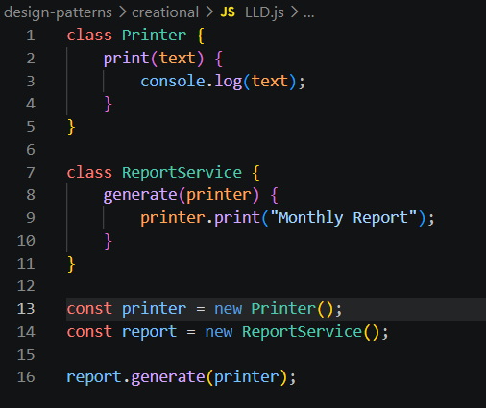
Notice:
- ReportService doesn't own Printer
- It only uses it temporarily
Dependency
ReportService -----> Printer

Real Life
- Chef uses Knife
- Customer uses Payment Gateway
- API Service uses Logger
The object is used only during execution.

2. Association (Knows About)
Association means one object knows another object.
Usually stored as a property.
Unlike dependency, the relationship lasts longer.
Driver -------------> Car
The driver knows which car he drives.
JavaScript
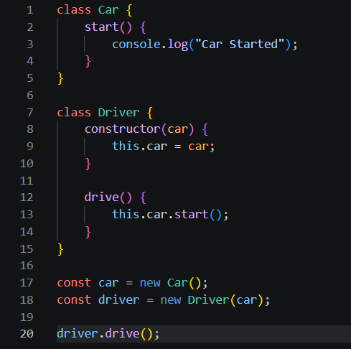
Here,
Driver stores
this.car
That makes it an Association.

Lifecycle
If Driver dies
Car still exists.
If Car is destroyed
Driver still exists.
Neither owns the other.

Association Diagram
Driver ----------------> Car
Simple relationship.
No ownership.

3. Aggregation (Weak Has-A)
Aggregation is a special Association.
One object contains another object.
But...
The contained object can exist independently.
Think:
Department
|
| has Professors
▼
Professor
If department closes...
Professors don't disappear.
They join another department.
JavaScript
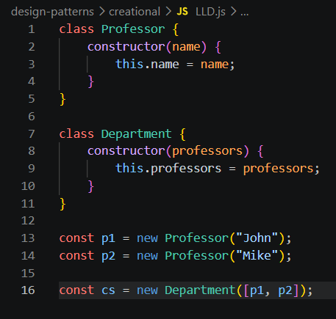
Notice
Department didn't create
Professor
Someone else created them.
Department only stores references.
Diagram
Department ◇-------- Professor
Empty diamond = Aggregation
More examples
Company → Employees
Company
|
Employees
Company shuts down
Employees still exist.
Team → Players
Delete Team
Players still exist.
Library → Books
Books can move to another library.

Aggregation Rule
Part is created outside.

Whole only stores it.

4. Composition (Strong Has-A)
Composition means
The whole object owns the parts completely.
The part cannot exist independently.
Think of
House
|
Rooms
A room without a house makes no sense.
Destroy house
↓
Rooms disappear.
JavaScript
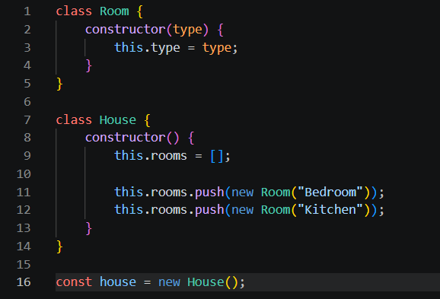
Notice
House creates Room.
Nobody passes Room from outside.
new Room()
exists inside House.
Diagram
House ◆-------- Room
Filled diamond = Composition
More examples
Car → Engine
Engine belongs to that car.
Human → Heart
Heart belongs to human.
Book → Pages
Pages belong to that book.
Computer → Motherboard
Motherboard belongs to computer.

Composition Rule
Whole creates the part.

Whole destroys the part.

Aggregation vs Composition
This is the favorite interview question.

Aggregation
Professor created first

↓

Department uses Professor
Professor
\
\
Department
Destroy Department
Professor survives.
Code
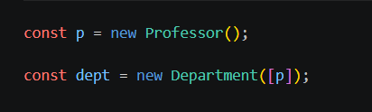
Professor already existed.

Composition
House creates Room
House
|
Room
Destroy House
Room disappears.
Code
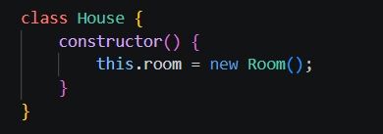
Room depends on House.

5. Inheritance (IS-A)
Inheritance means
One class is another class.
Dog is an Animal
Animal
▲
|
Dog
JavaScript
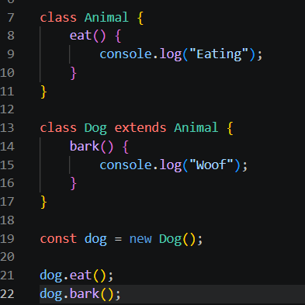
Dog gets all Animal behavior.
More examples
Car is a Vehicle

Lion is an Animal

Square is a Shape

6. Realization (Implements)
Realization means
A class promises to implement an interface (or contract).
JavaScript doesn't have interfaces natively, but conceptually:
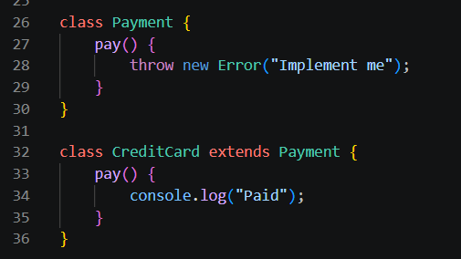
Payment
▲
|
CreditCard
In TypeScript:
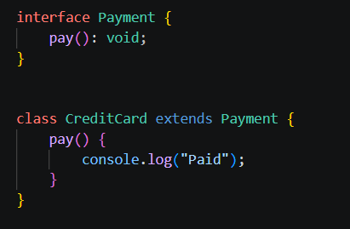

UML Symbols
Relationship | UML Symbol | Meaning
Dependency | - - -> | Uses temporarily
Association | ----> | Knows about
Aggregation | ◇----> | Weak Has-A
Composition | ◆----> | Strong Has-A
Inheritance | △ (solid line) | Is-A
Realization | △ (dashed line) | Implements

